**SUPERIOR UNIVERSITY LAHORE**

|  |
| --- |
|  |

**Faculty of Computer Science & IT**

**Semester Project**

**PROJECT REPORT**

**Restaurant Management System**

Project ID: **[write ID here Issued by FYP Manager]**

**Project Team**

|  |  |  |  |  |
| --- | --- | --- | --- | --- |
| **Student Name** | **Student ID** | **Program** | **Contact Number** | **Email Address** |
| Muhammad Usman Babar | Bcsm-f18-279 | BSCS | 03494637002 | Usmanbabar56@gamail.com |
| Hafiz Ali Hamza | Bcsm-f18-257 | BSCS | 03164479412 | Alibinramzan123@gmail.com |
| Hafiz Nasir | Bcsm-f17-301 | BSCS | 03164169396 |  |

**[Project Supervisor]**

Miss Sabah

**Project Report**

**Restaurant Management System**

**Change Record**

|  |  |  |  |  |
| --- | --- | --- | --- | --- |
| **Author(s)** | **Version** | **Date** | **Notes** | **Supervisor’s Signature** |
|  | 1.0 |  | <Original Draft> |  |
|  |  |  | <Changes Based on Feedback from Supervisor> |  |
|  |  |  | <Changes Based on Feedback From Faculty> |  |
|  |  |  | <Added Project Plan> |  |
|  |  |  | <Changes Based on Feedback from Supervisor> |  |
|  |  |  |  |  |
|  |  |  |  |  |
|  |  |  |  |  |
|  |  |  |  |  |
|  |  |  |  |  |

**APPROVAL**

|  |  |
| --- | --- |
| **Project Supervisor** | |
| Comments: ___________________________________________________________________ | | |
| _____________________________________________________________________________ | | |
| Name:______________________________ |  | |
| Date:_______________________________ | Signature:__________________________ | |

|  |  |
| --- | --- |
| **Project Manager** | |
| Comments: ___________________________________________________________________ | |
| _____________________________________________________________________________ | |
|  |  |
| Date:_______________________________ | Signature:__________________________ |

|  |  |
| --- | --- |
| **Head of the Department** | |
| Comments: ___________________________________________________________________ | |
| _____________________________________________________________________________ | |
|  |  |
| Date:_______________________________ | Signature:__________________________ |

# Dedication

*We would like to devote this document to our adored Parents who persuade us a lot who have never failed to grant us monetary or moral support, for providing us all which we need throughout the time we developed our system and for schooling us that even the prime task can be accomplished if it is completed one step at a time.*

*This work is dedicated to my respected teacher (Miss Sabah)*

# Acknowledgements

It is by the Grace of Allah Almighty, the Lord and Creature of this Universe. Whose power and Glory all things are accomplished and his Prophet (P.B.U.H) who is, forever, a torch of guidance and knowledge for humanity as whole. We thank to Allah Almighty who made it possible for us to complete this project and to overcome all the difficulties faced during the course of this project. We would like to pay our thanks to our project supervisor MISS SABAH Lecturer at Superior University for specialist advice and support. It was due to his knowledge and skill that we were able to handle problems faced during the project. His kind, accommodating, Suggestion, Constant Encouragement and generous supervision made this project easy for us. We would also like to thank all the teachers of computer science and IT department who helped us a lot during all the semesters we have studied so far and assisted us at becoming good computer scientists. We are also grateful to our family for their help and support when we needed it the most.

# Executive Summary

This project is insight into the design and implementation of a Restaurant Management System.

The primary aim of is to improve accuracy in the Restaurant Management System.

Today management is one of the most essential features of all form. This is Restaurant management system; it is used to manage most Restaurant related activities in the Restaurant including records of goods, food and sale, purchase, order, maintain stock as well as records of employees working in Restaurant and the record of companies deliver Goods into Restaurant store.

# Table of Contents

Dedication iv

Acknowledgements v

Executive Summary vi

Table of Contents vii

List of Figures ix

List of Tables x

Chapter 1 1

Introduction 1

1.1. Background 2

1.2. Motivations and Challenges 2

1.3. Goals and Objectives 2

1.4. Literature Review/Existing Solutions 2

1.5. Gap Analysis 2

1.6. Proposed Solution 2

1.7. Project Plan 3

1.7.1. Work Breakdown Structure 3

1.7.2. Roles & Responsibility Matrix 3

1.7.3. Gantt Chart 3

1.8. Report Outline 3

Chapter 2 4

Software Requirement Specifications 4

2.1. Introduction 5

2.1.1. Purpose 5

2.1.2. Document Conventions 5

2.1.3. Intended Audience and Reading Suggestions 5

2.1.4. Product Scope 5

2.1.5. References 6

2.2. Overall Description 6

2.2.1. Product Perspective 6

2.2.2. Product Functions 6

2.2.3. User Classes and Characteristics 6

2.2.4. Operating Environment 7

2.2.5. Design and Implementation Constraints 7

2.2.6. User Documentation 7

2.2.7. Assumptions and Dependencies 7

2.3. External Interface Requirements 8

2.3.1. User Interfaces 8

2.3.2. Hardware Interfaces 8

2.3.3. Software Interfaces 8

2.3.4. Communications Interfaces 9

2.4. System Features 9

2.4.1. System Feature 1 9

2.4.1.1. Description and Priority 9

2.4.1.2. Stimulus/Response Sequences 9

2.4.1.3. Functional Requirements 9

2.4.2. System Feature 2 10

2.4.2.1. Description and Priority 10

2.4.2.2. Stimulus/Response Sequences 10

2.4.2.3. Functional Requirements 10

2.4.3. System Feature 3 (and so on) 11

2.5. Other Nonfunctional Requirements 11

2.5.1. Performance Requirements 11

2.5.2. Safety Requirements 11

2.5.3. Security Requirements 12

2.5.4. Software Quality Attributes 12

2.5.5. Business Rules 12

2.6. Other Requirements 12

Chapter 3 13

Use Case Analysis 13

3.1. Use Case Model 14

3.2. Fully Dressed Use Cases 14

Chapter 4 15

System Design 15

4.1. Architecture Diagram 16

4.2. Domain Model 16

4.3. Entity Relationship Diagram with data dictionary 16

4.4. Class Diagram 17

4.5. Sequence / Collaboration Diagram 17

4.6. Operation contracts 17

4.7. Activity Diagram 18

4.8. State Transition Diagram 18

4.9. Component Diagram 18

4.10. Deployment Diagram 19

4.11. Data Flow diagram [only if structured approach is used - Level 0 and 1] 19

Chapter 5 20

Implementation 20

5.1. Important Flow Control/Pseudo codes 21

5.2. Components, Libraries, Web Services and stubs 21

5.3. Deployment Environment 21

5.4. Tools and Techniques 22

5.5. Best Practices / Coding Standards 22

5.6. Version Control 22

Appendices 23

Appendix A: Information / Promotional Material 24

Reference and Bibliography 27

Index 29

# List of Figures

1.1 Caption of first figure of first chapter 6

1.2 Caption of second figure of first chapter 7

2.1 Caption of first figure of second chapter 14

2.2 Caption of second figure of second chapter 22

2.3 Caption of third figure of second chapter 26

5.1 Caption of first figure of fifth chapter 49

5.2 Caption of second figure of fifth chapter 49

# List of Tables

1.1 label of first table of first chapter 6

1.2 label of second table of first chapter 7

2.1 label of first table of second chapter 14

2.2 label of second table of second chapter 22

2.3 label of third table of second chapter 26

5.1 label of first table of fifth chapter 49

5.2 label of second table of fifth chapter 49

# Chapter 1

# Introduction

# Chapter 1: Introduction

"Online Restaurant Management System" is a web application. This system is developed to automate day to day activity of a restaurant. Restaurant is a kind of business that serves people all over world with ready-made food. This system is developed to provide service facility to restaurant and also to the customer. This restaurant management system can be used by employees in a restaurant to handle the clients, their orders and can help them easily find free tables or place orders. The services that are provided is food ordering and reservation table management by the customer through the system online, customer information management and waiter information management, menu information management and report. The restaurant menu is organized by categories (appetizers, soups, salads, entrees, sides and drinks) of menu items. Main objective builds the system this is to provide ordering and reservation service by online to the customer. Each menu item has a name, price and associated recipe. A recipe for a menu item has a chef, preparation instruction sand associated ingredients. With this system online, ordering and reservation management will become easier and systematic to replace traditional system where are still using paper. To resister a meal online, the customer has to become a member first then he can access the later part of the site. This project to facilitate customer for make online ordering and reservation. The option of becoming member was only an attempt to avoid (to some extent) placing the fake bookings.

## Background

The project is developing because; many restaurants have a lot difficult to manage the business such as customer ordering and reservation table. If the customer book an order and later wants to cancel the order, he is permitted to do this only within a specific time period. By using manual customer ordering it is difficult for the waiter to keep the correct customer information and may lose the customer information. The customer is also given the facility to view the status of the order to determine if it is ready.

## Motivations and Challenges

Nowadays, many restaurants manage their business by manual especially take customer ordering. In traditional booking system, a customer has to go to restaurant or make a phone call in order to get his meal reserved. Today, restaurant waiter takes the customer ordering by manual system with using paper. Customer does some formal conversation like hello, hi, etc. Then he demands for today’s menu and do some discussion over menu items then he orders. It takes 5 to 10 minutes to book the order and waiter book the order on paper so there is probability of lost and duplication of customer information. Restaurant management system puts the order in a queue with specific priority according to time and quantity, and then a cook is assigned for the specific order to complete it.

## Goals and Objectives

Our purpose is to develop this system to give the best environment to the

people enjoy their meal comfortably. The order taken and other things is done

by handy devices like a smartphone rest of the while the world is using this kind

of technology. In Pakistan develop country there is no trend of using these kind

of technology our main purpose of this system is to make the people aware the

people to uses technology. This is the first technology implemented in Pakistan

Costumer will have a quite dependable, active and dynamic system.

## Literature Review/Existing Solutions

As far as we are concerned with existing solution, we found some solutions that have been implemented but they are very limited functionally and more importantly these solutions don’t exist in our country. We have compiled our solution that includes previously implemented and many new features. Existing solutions are more confusing and less easy to understand RMS will be more optimized solution to the problem. The previously designed projects are with limited functionality. The functionality that is used in this our RMS is more concerned about this current era of technology people.

## Gap Analysis

Now traditionally restaurants lack online reservation of the table, and many restaurants don’t provide discount to their registered customers.

Our purpose is developing a system which can let users to registers their selves and have discounts on our food. Also, users can order food from their home. User can view prices of the food online.

User can view the tables available in the restaurant, and the best time to bring their family for dinning.

## Proposed Solution

Our purpose to develop this RMS is to give the best environment to the people enjoy their meal comfortably. The order taken and other things is done by handy devices like a smartphone rest of the while the world is using this kind of technology .In Pakistan develop country there is no trend of using these kind of technology our main purpose of this system is to make the people aware the people to uses technology. This is the first technology implemented in Pakistan Costumer will have a quite dependable, active and dynamic system.

The Solution includes:

* Full interaction of user with the UI.
* Time and cost effective.
* Making the order taking easy for the user.
* Maintenance of the staff record.
* It is a Business Efficient
* Discount for the *star customer
* It is a Business effective Full interaction of user with the UI.

## Project Plan

Restaurant Management System will follow the standard development life cycle, however during the requirement phase, the cycle will be more iterative. During the testing phase also the cycle will be more iterative as the application is supposed to communicate with the external systems.

|  |  |  |
| --- | --- | --- |
| Life Cycle Stage | Effort (Days) | Percentage of effort (%) |
| Requirement gathering / Analysis  Detail Design  Coding, Unit Testing and Code Review  Data Conversion / Migration  System Integration Testing  User Acceptance Test  Training  Implementation  Maintenance  Project Management | 20  10  50  0  5  3  0  10  0  0 | 2.56  12.82  64.10  0  6.41  1.28  0.0  12.82  0  0 |

## Work Breakdown Structure

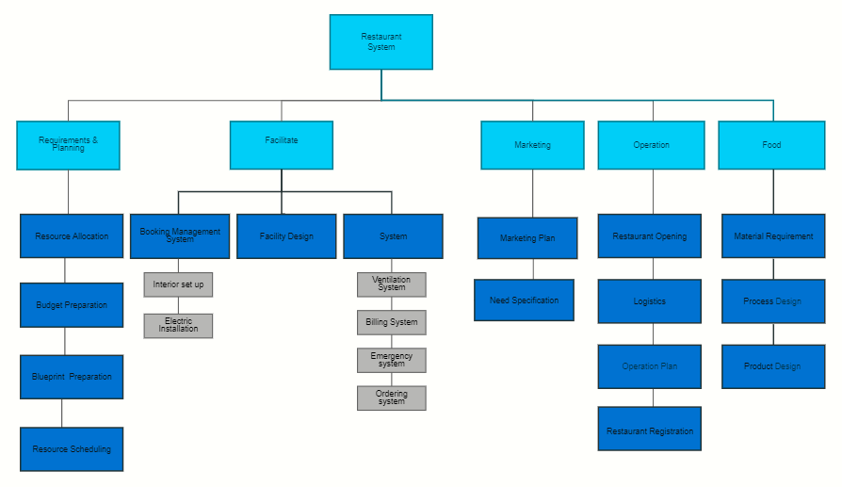

## Roles & Responsibility Matrix

|  |  |  |  |  |  |
| --- | --- | --- | --- | --- | --- |
|  |  |  |  |  |  |
| **WBS #** | **WBS Deliverable** | **Activity #** | **Activity to** | **Duration** | **Responsible** |
|  |  |  | **Complete the** | **(# of Days)** | **Team** |
|  |  |  | **Deliverable** |  | **Member(s) &** |
|  |  |  |  |  | **Role(s)** |
|  |  |  |  |  |  |
| 01 | Requirement | 1.0 |  | 6 | All of us |
|  | gathering |  |  |  |  |
|  |  |  |  |  |  |
| 02 | System Design | 1.1 |  | 7 | Ali Hamza, |
|  | flow |  |  |  | M Usman Babar |
|  |  |  |  |  |  |
| 03 | Database design | 1.2 |  | 4 | All of us |
|  |  |  |  |  |  |
|  |  |  |  |  |  |
| 04 | Database | 1.3 |  | 2 | Ali Hamza, |
|  | implementation |  |  |  | M Usman Babar |
|  |  |  |  |  |  |
| 05 | GUI design | 1.4 |  | 5 | All of Us |
|  |  |  |  |  |  |
| 06 | GUI & Database |  |  | 4 | All of Us |
|  | Integration |  |  |  |  |
|  |  |  |  |  |  |
| 07 | Coding | 1.5 |  | 10 | All of us |
|  |  |  |  |  |  |
|  |  |  |  |  |  |
| 08 | Bug Fixing | 1.6 |  | -- | Hafiz Nasir |
|  |  |  |  |  | M Usman Babar |
|  |  |  |  |  |  |
| 09 | Final Testing | 1.7 |  | 2 | All of Us |
|  |  |  |  |  |  |
|  |  |  |  |  |  |

## Gantt Chart

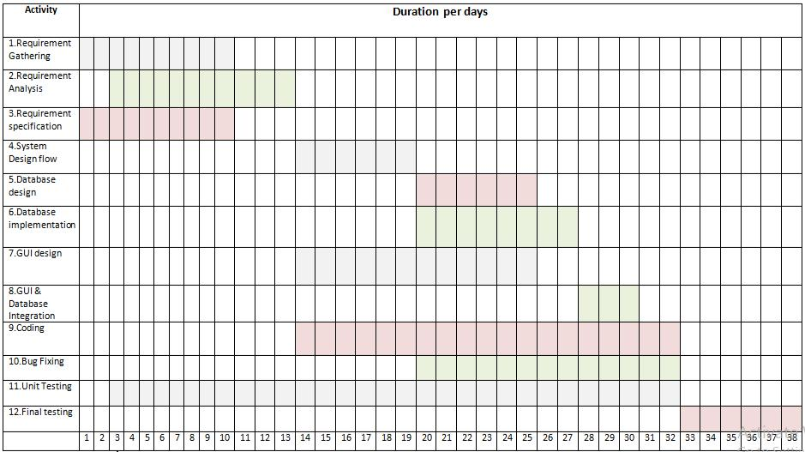

## Report Outline

This article includes all the information of our project included.

1. Introduction

2. Basics of functionality

3. Provided facilities.

4. Extreme with another competitor

5. Functionality of the system

6. User friendly interface

7. Provide complete cost estimation

8. Project plan

# Chapter 2

# Software Requirement Specifications

**Chapter 2:** Software Requirement Specifications

## Introduction

## Software Requirement Specification (SRS) is the initial point of the software developing activity. As system grew more complex, it becomes difficult to keep pace with the goals of the entire system correctly. Hence, the need for the requirement phase arose. The software project initiated according to the client needs. The SRS is the means of translating the ideas of clients (the input) into a formal document (the output of the requirement phase.) This SRS covers the entire requirement needed to create the SRMS application. It includes everything from functional requirements to the workflow of the project

## Purpose

The purpose of the Software Requirement Specification is to reduce the communication gap between the clients and the development team. Software Requirement Specification is the medium through which the client and user needs are to be specified accurately. It forms the basis of software development. A good SRS should satisfy all the parties involved in the system. The software requirements specification document enlists enough and necessary requirements that are required for the project development. Software requirements specification permits a rigorous assessment of requirements before design can begin and reduces later redesign.

## Document Conventions

This document is written in a simple English language 12pt body font size, 14pt headings font Size and Calibri font style. Every heading starts with number bullets to describe the sequence of Document.

## Intended Audience and Reading Suggestions

This document is written for developers, owner and users of restaurant management system.

## Product Scope

Restaurant management system should provide the complete management for restaurant. It should provide the accurate results to fulfill user requirements. Restaurant management system shall deploy to a local Restaurant to convert their Manual system into a computerized system.

## References

1. Interviews with client.
2. Interviews with users.
3. Visiting different restaurant.
4. Taking review from hoteliers.

## Overall Description

* **Product perspective:**

The product (SRMS) that we are building is linked to database (SQL Plus). The database is linked to Oracle forms & reports application which is operated by an administrator. The desktop application which is developed in Oracle Forms manages the orders & track record of all the inventory modules of restaurant and update our database. In other word the product that we are building is interconnected within itself.

* **System interfaces:**

This should list each system interface and identify the functionality of the software to accomplish the system requirement and the interface description to match the system.

* **User interfaces:**

As it is mentioned above this product would contain numerous user interfaces ranging of that from Desktop app, Forms, reports, web to android. The list below shows the user interfaces that are comprised in Oracle, Webpages and android app respectively. There are numerous features that we are trying to embed in this particular software so quite a few screens are used to show clarity amongst different interfaces.

## Product Perspective

Restaurant management system is a follow-on member of a Restaurant management systems but it as a not a replacement of existing system. Restaurant management is specially built for restaurant that was running under a manual management system. Restaurant management system should fulfill the requirements of Restaurant.

## Product Functions

Restaurant management system will perform the following functions:

1. **Login**

a) Admin login

b) User login/employee/pharmacist

2. **Food record maintenance**

* View food
* Add food
* Price of food
* Menu
* Drinks

**3**. **Employee record maintenance**

**A. add new employee**

a) Name

b) Date-of-birth

c) Contact/email

d) salary record

e) joining date

f) role

g) CNIC

**B. Remove employee**

**1. Supplier**

a) Add supplier

b) Remove supplier

c) Display supplier status

**2. Supplier company**

1. Record of supplier

**3. Restaurant**

a) Record of restaurant

## User Classes and Characteristics

The restaurant management system should be used by accountant who shall manage the records of foods, and the admin who should manage the record of employees.

## Operating Environment

• Mac OS cheetah or above, Linux mint or above, Windows 7 or above.

• 4 GB RAM.

• 50 GB HDD.

• I3 2.5GHz or above.

• XAMPP

• Java SE 8 or above.

## Design and Implementation Constraints

The restaurant management system is developed by using html, bootstrap, css, js and Java programming language for Interface, data structures and object-oriented programming and the local host server including MySQL database.

## User Documentation

In this documentation of the user must follow the instructions regulate by the software.

* User Manual
* Online Delivery
* Policies
* Privacy

## Assumptions and Dependencies

The application target only restaurant managers & customers.

* Every user & manager must have a reliable internet connection.
* The application would be built with Oracle form tools & reports, PHP & android.
* If there are any updating in the versions that have to be dealt SRMS.
* Users should have basic knowledge of the system
* Catalogue or manual would be provided.

## External Interface Requirements

## User Interfaces

## User interface consists of GUI including:

## Buttons

## Logout

## Exit

## Action buttons

## Texts

## Text fields

## Labels

## Hardware Interfaces

* Mac OS cheetah or above, Linux mint or above, Windows 7 or above.
* 4 GB RAM.
* 50 GB HDD.
* 2.5GHz or above**.**

## Software Interfaces

1. IntelliJ beans ide 8.2

* Libraries

1. Vs Code
2. Jdk 1.8
3. MySQL jdbc driver
4. MySQL Database

* XAMPP local host

## Communications Interfaces

The restaurant management system is a stand-alone application so that no internet is needed. It Should operate in a single computer system.

## System Features

As our basic purpose of this app is to save time and cost of the restaurant owners, so for this, we are using Oracle forms & reports to make ease for managers. There will be very less bargaining for the fair as we are providing an estimated fair within the app for the users. Secondly there will be no need to take orders manually on paper and difficulty of daily records.

## System Feature

* 1. Login
  2. Food record maintenance

1. Add new food
2. Search food
3. Add food to the cart
4. Generate bill
   1. Employee record maintenance
      * 1. Add employee
        2. Update employee
        3. Delete employee
   2. Supplier record
   3. Add supplier
   4. Update supplier
   5. Delete supplier
5. supplier company record
   1. Add supplier company
   2. update supplier company
   3. delete supplier company
6. Food company
7. Restaurant record

## Description and Priority

Our application is primarily designed for the restaurant owners &

customers to make order with in the restaurant. Managers will be provided a

dashboard to make orders. He can create/update customer profile. Manager

can track the sales and purchase reports. Users can access the mobile

application or website to make order

## Stimulus/Response Sequences

**Stimulus:**

Stimulus: 1 User logins the app entering password button launch the app.

Stimulus: 2 User touch the Create order Button.

Stimulus: 3 User can view the Promotions.

Stimulus: 4 User can Confirm the Order.

**Admin:**

Stimulus: 1 Admin logins with username and password fields.

Stimulus: 2 Admin clicks the Create Order button.

Stimulus: 3 Admin clicks on the update/Edit Order button.

Stimulus: 4 Admin clicks the delete button.

Stimulus: 5 Admin clicks the Create Customer button.

Stimulus: 6 Admin clicks the create User Button.

Stimulus: 7 Admin clicks the Create Items/Category button.

Stimulus: 8 Admin clicks the Sales & Reports Button. **App:**

Response: The user will sign in and a screen will be loaded with all the features

of app.

Response: Menu of food will be appeared.

Response: User can access the food items.

Response: User tracking will be started.

Response: App will calculate the order according to the desired order.

Response: Settings will be managed by the app.

Response: Hot deals also display.

**Admin**:

Response: The system will open a new screen after login.

Response: The system will add and save the Order details.

Response: The system will update the order record.

Response: The system will delete the Order details.

Response: The system will make the user data available to the admin.

Response: The system will confirm the valid users.

Response: The system will save the Order details and time.

## Functional Requirements

The pharmacy management system has following functional requirements

* Login

|  |  |
| --- | --- |
| Username | Admin |
|  |  |
| Password | 123456 |
|  |  |

● Add products

|  |  |  |  |  |
| --- | --- | --- | --- | --- |
| Food Id | |  | 1 |  |
|  | |  |  |  |
| Food Name | |  | Biryani |  |
|  | |  |  |  |
| Food type | |  | Rice |  |
|  | |  |  |  |
| Food expiry date | |  | 20-04-2020 - 6am |  |
|  | |  |  |  |
|  |
|  |
|  |
|  |
|  |
|  | | |  | |

|  |  |  |  |  |  |  |
| --- | --- | --- | --- | --- | --- | --- |
|  | |  |  | | | |
| ● | add employee | | | | |  | |  | |  |
|  | | | |  |  |  | |  | |  |
| Employee Id | | | | |  | 1 | |  | |  |
|  | | | |  |  |  | |  | |  |
| Employee Name | | | | |  | Usman | | | |  |
|  | | | |  |  |  | |  | |  |
| Employee CNIC | | | | |  | 123456789 | |  | |  |
|  | | | |  |  |  | |  | |  |
| Employee Address | | | | |  | House #111, M town Lahore | | | |  |
|  | | | |  |  |  | |  | |  |
| Employee Gender | | | | |  | Male | | | |  |
|  | | | |  |  |  | |  | |  |
| Employee salary | | | | |  | 20,000 | |  | |  |
|  | | | |  |  |  | |  | |  |
| Restaurant Id | | | | |  | 1 | |  | |  |
|  |  | | |  |  |  | |  | |  |
| ● | generate bill | | | | |  | |  | |  |
|  |  | | |  | |  | | | | |
|  | Food name | | |  | | biryani | |  | |  |
|  |  | | |  | |  | |  | | |
|  | Food quantity | | |  | | 1 plate | |  | |  |
|  |  | | |  | |  | |  | |  |
|  | Food price | | |  | | 100 | |  | |  |
|  | | | |  | |  | |  | | |
| Total amount | | | |  | | 100 | |  |

|  |  |  |  |  |  |
| --- | --- | --- | --- | --- | --- |
|  |  | * Supplier |  |  |  |
|  |  | Supplier Id |  | 10 |  |
|  |  |  |  |  |  |
|  |  | Supplier Name |  | Nasir Sahib | |
|  |  |  |  |  |  |
|  |  | Supplier contact |  | 0333-3333333333 |  |
|  |  |  |  |  |  |
|  |  | Product id |  | 1 |  |
|  |  |  |  |  |  |

* Supplier company

|  |  |
| --- | --- |
| Company-Id | 133 |
|  |  |
| Company-Name | Sunshine |
|  |  |
| Comp-Contact | 052-93746443 |
|  |  |
| Supplier-id | 10 |
|  |  |

**REQ-SF:**

Logical database requirements.

**REQ-SF:**

Design Constraints:

**REQ-SF:**

Performance requirements

## Other Nonfunctional Requirements

## Performance Requirements

As our basic purpose of this app is to save time and cost of the restaurant owners, so for this, we are using Oracle forms & reports to make ease for managers. There will be very less bargaining for the fair as we are providing an estimated fair within the app for the users. Secondly there will be no need to take orders manually on paper and difficulty of daily records.

## Safety Requirements

* Each user must be logout after finishing work.
* Each login (username, password) must be hidden from unauthorized persons.

## Security Requirements

The mobility domain has a privacy sensitive nature, in order to produce a

practicable offering for the user we will have to construct a simple, opaque

system that can be understood and trusted by the people that are using it. In

order to build trust with the users of our system, the system can make use of

the following strategies:

* Ammonization & aggregation, so that information may be shared safely without disclosing private information.
* Encryption, for all facts that is privacy susceptible, but must be persisted on the server in order for fundamental functionality
* Open source / disclose safety policies & practices
* Give charge to end-users over private data

## Software Quality Attributes

**Reliability**:

Regular checks would be applied to the data that would make sure that

data is clean in terms of its reliability. SRMS will ensure the privacy of user job status and ensure full control over job execution, so that resource allocation is not possible without administrator authority.

**Availability**:

The admin panel will run on the admin’s pc and will contain an Access database. Access is already installed on this computer and is a Windows operating system.

**Security:**

The mobility domain has a privacy sensitive nature, in order to produce a

practicable offering for the user we will have to construct a simple, opaque

system that can be understood and trusted by the people that are using it. In

order to build trust with the users of our system, the system can make use of

the following strategies:

* Ammonization & aggregation, so that information may be shared safely without disclosing private information.
* Encryption, for all facts that is privacy susceptible, but must be persisted on the server in order for fundamental functionality
* Open source / disclose safety policies & practices
* Give charge to end-users over private data

**Maintainability:**

All the data would be effectively maintained by the SRMS application, the web panel will be on a server with high speed Internet capability. The physical machine to be used will be determined by the administrators themselves. The software developed here assumes the use of a tool such as Oracle forms & reports for connection between the Web pages and the

database. The speed of the connection will depend on the hardware used rather than characteristics of this system.

**2.3.6.5 Portability:**

Any single member listed in the website could avail the services of this

product. The website would be sent to a domain or sub domain as we are

making use of the GCM service there is no issue in the transfer of data.

## Business Rules

**System mode:**

The system would work normal under every condition but if a malicious activity is caught the emergency mode would be turned on and the system would stop sending data.

**User class**:

Different set of operations are provided to different set of user class’s i.e.

All the authority is provided to the admin who is receiving and confirming the Order but user has only got the permission or right to view and update his/her information.

## Other Requirements

**1 Safety Requirements**

* Each user must be logout after finishing work
* Each login (username, password) must be hidden from unauthorized persons.

**2 Admin**

Admin has full access of the system. Admin can enter, update, and delete stock.

Admin also has access to employee’s record. She/he could add, remove, and view the employee

data.

**3 Manager**

Pharmacist could order the stock. Check the stock and maintain the stock and he/she can work

as cashier.

# Chapter 3

# Use Case Analysis

**Chapter 3:** System Analysis

This chapter consists of use case, use cases and fully dressed use case modeling, which is mostly used to model interactions between

a system and external actors (users or other systems).

## Use Case Model

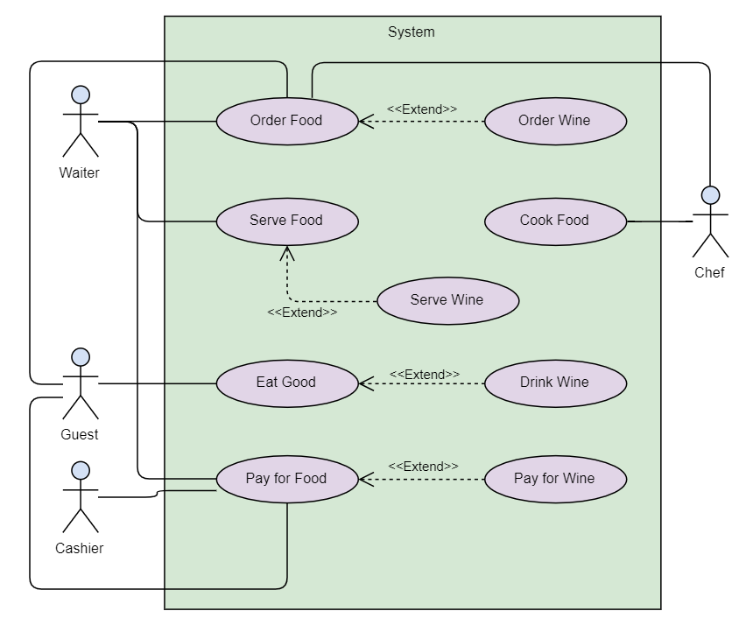

## Use Cases

**Waiter use case:**

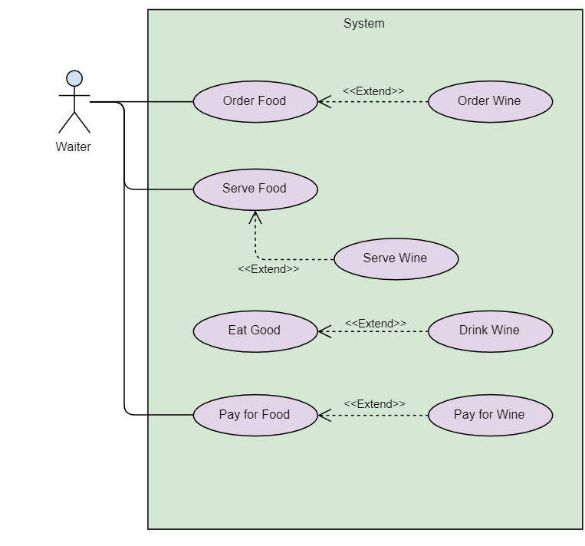

**Guest use case:**

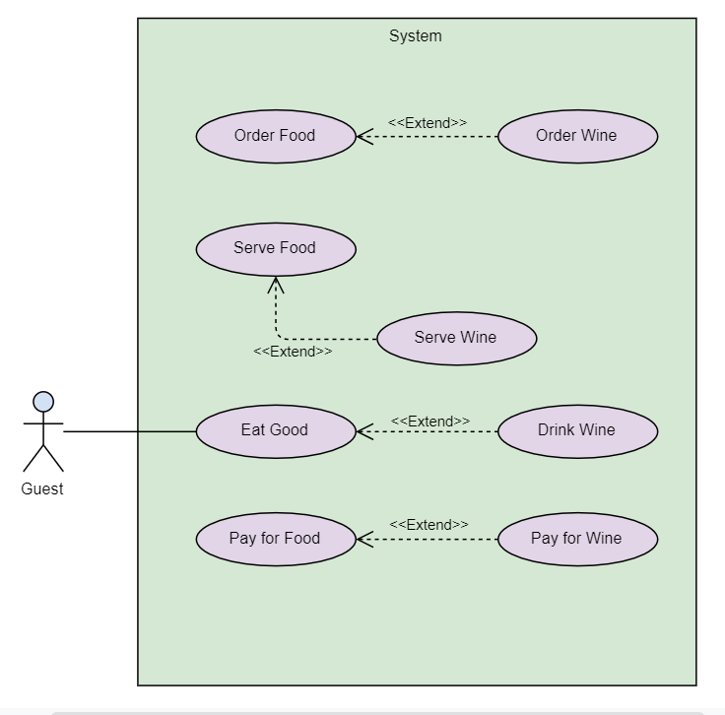

**Cashier Use case**

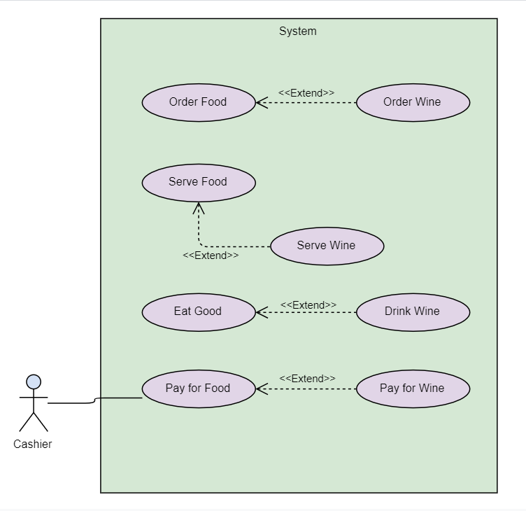

**Chef Use case**

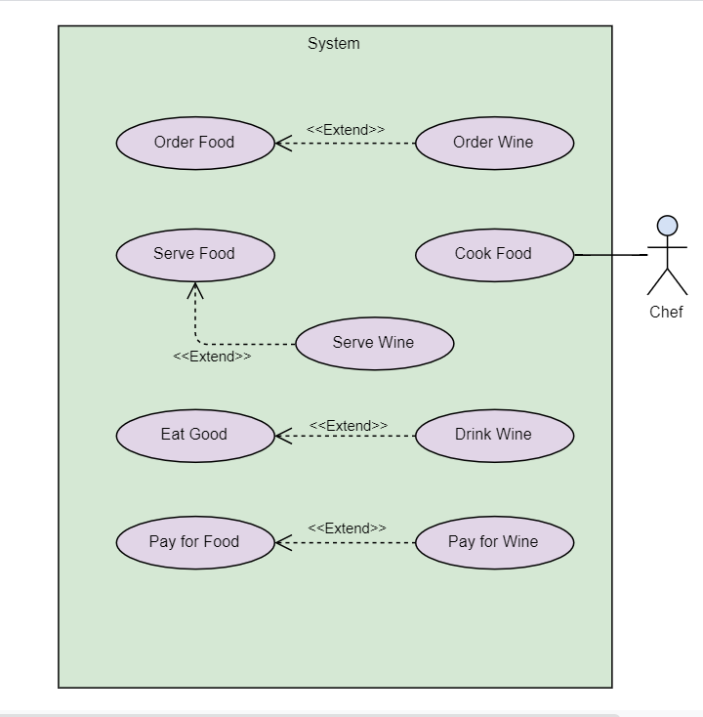

## Fully Dressed Use Cases

**Order Food**

The fully dressed use case specification of Order Food.

|  |  |  |
| --- | --- | --- |
| **Number** | 1 | |
| **Name** | Order Food | |
| **Summary** | Waiter Make order trough | |
| **Priority** | 5 | |
| **Preconditions** | Waiter must have logged into his account through valid pin code | |
| **Post conditions** | Waiter had Make order. | |
| **Primary Actors** | Waiter, Cashier | |
| **Secondary Actors** | Chef | |
| **Trigger** | Waiter choose to make order | |
| **Main Scenario** | **Step** | **Action** |
| 1. | System will ask for pin |
| 2. | Waiter will enter pin to login |
| 3. | System will ask to choose food category |
| 4. | Waiter will choose the category |
| 5. | System will ask to choose the food name and type |
| 6. | Waiter will enter food name and type |
| 7. | System will generate a receipt |
| 8. | Waiter will take the receipt |
| 9. | System will display order successfully made |
|

* **Generate Bill**

The fully dressed use case specification of Generate Bill.

|  |  |  |
| --- | --- | --- |
| **Number** | 2 | |
| **Name** | Generate Bill | |
| **Summary** | Cashier will generate the bill | |
| **Priority** | 5 | |
| **Preconditions** | Cashier must have logged into his account through valid pin code | |
| **Post conditions** | Cashier had generated a bill receipt for the Guest | |
| Waiter, Cashier | Waiter, Cashier | |
| **Secondary Actors** | Chef | |
| **Trigger** | Cashier choose to generate bill and receipt | |
| **Main Scenario** | **Step** | **Action** |
| 1. | System will ask for the table number |
| 2. | Cashier will enter the table number |
| 3. | System will ask for the Food and drinks type |
| 4. | Cashier will enter the Food and drink type |
| 5. | System will ask to enter order items |
| 6. | Cashier will enter the order items |
| 7. | Machine will generate the receipt |
| 8. | Cashier will take the receipt |
| 9. | System will display the message of Bill generated |

# Chapter 4

# System Design

**Chapter 4:** System Design

This Chapter consists of system design of:

* Class Diagram
* State Diagram
* Architecture Diagram
* Sequence Diagram

## Architecture Diagram

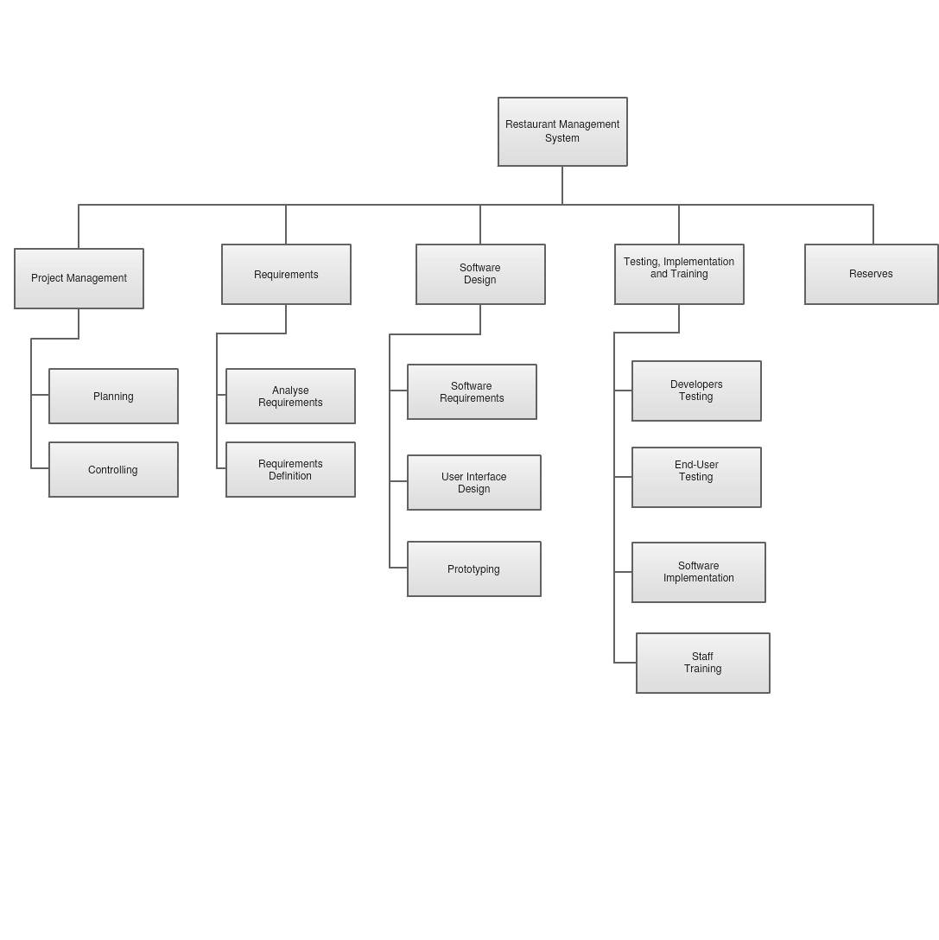

## Entity Relationship Diagram with data dictionary

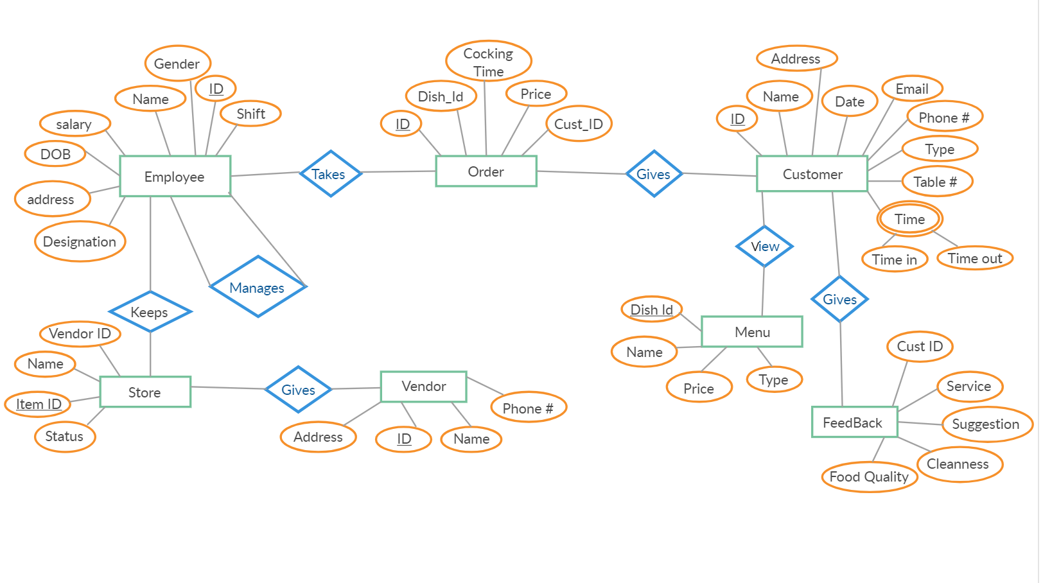

## Class Diagram

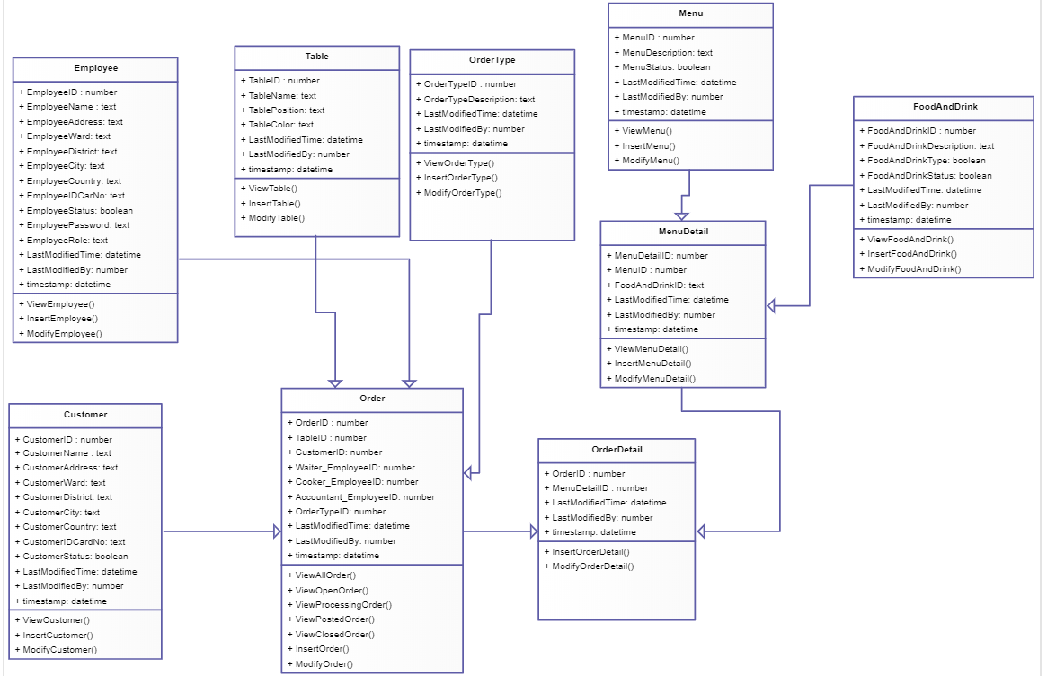

## Sequence / Collaboration Diagram

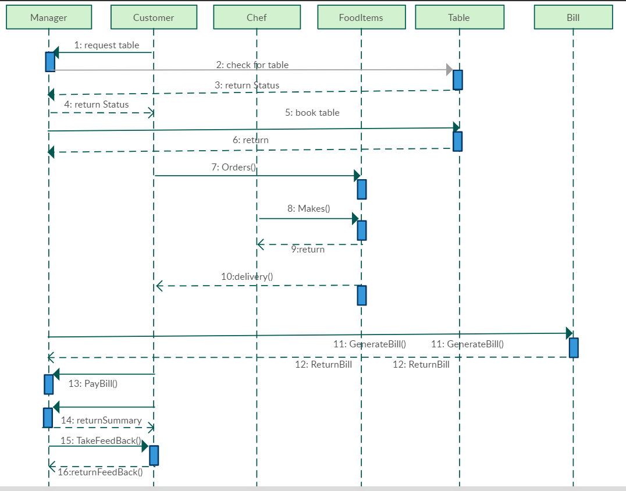

## Activity Diagram

Process Order

Place Order

Print Receipt Confirmation

Update Stock Availability

Assign Order to Customer table

Offer

Alternative

Meal

Terminate Service

Confirm Order

Place order

Offer take away

Terminate order

Accept customer In

Check table Availability

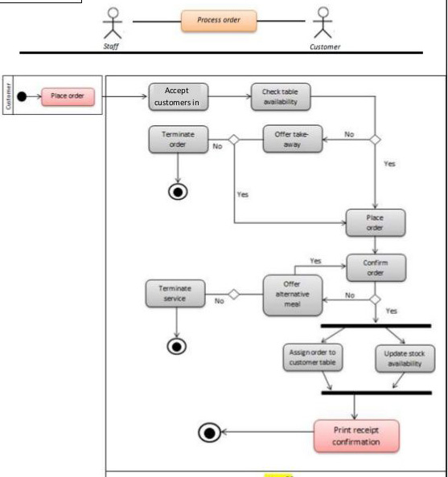

## State Transition Diagram

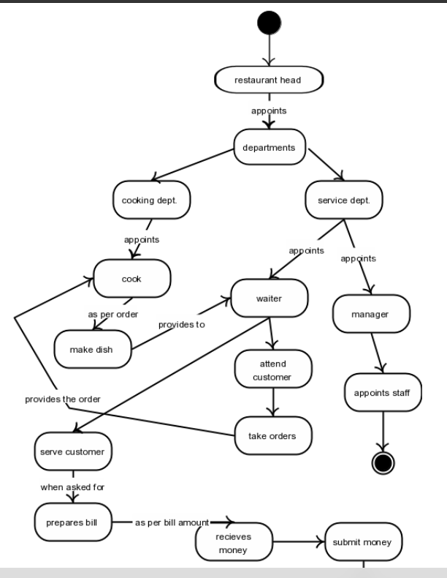

# Chapter 5

# Implementation

**Chapter 5:** Implementation

This chapter is about implementation of Restaurant management system, the tools and

techniques, coding standards, flow of program. It should help to understand how much this

system is efficient and sufficient to meet functional requirements

## Important Flow Control/Pseudo codes

This document describes the project implementation for developing the **RESTAURANT MANAGEMENT SYSTEM**. The project implements Android, Web and MySQL. The project will be capable of running on phones devices, as well on pc and desktop, although the project is designed primarily around Android Devices with IOS 5.0 or later android version and for IOS 9.0 or later.

## Components, Libraries, Web Services and stubs

Restaurant management system is based on Web Development HTML5, CSS, Bootstrap, PHP and Java language including Database queries are based on stored procedures, triggers

## Deployment Environment

Our software required a WEB environment to work fully functional. It also can work on mobiles, tablets but it may lack some features on small devices.

## Tools and Techniques

Following Tools which are used:

* HTML
* CSS
* MYSQL
* XAMMP Server
* PHP
* Bootstrap
* IntelliJ Ide.
* VS Code.

Different algorithm and web techniques are used for this system.

## Best Practices / Coding Standards

MYQSL Database, Java Web coding standards are used to implement Restaurant management

system. Java language has some constraints that should fulfill to acquire the accurate results

Code is efficient and can be reused.

Some coding Standards must be followed like:

• Defined Life Cycle

• Stable Requirements and Scope

• Defined Organization, Systems, and Roles

• Quality Assurance

• Planned Commitments

• Scope and mission

## Version Control

A system of version control is useful for documents which are likely to be revised and redrafted and where you might need to keep a record of how the document changed over time

**- Git and GitHub**

**Git** is a free and open source distributed version control system designed to handle everything from small to very large projects with speed and efficiency. It is a distributed revision control system with an emphasis on speed, data integrity, and support for distributed, non-linear workflows.

**GitHub** is a Web-based Git version control repository hosting service. It is mostly used for Computer Code It offers all of the distributed version control and source code management (SCM) functionality of Git as well as adding its own features. It provides access control and several collaboration features such as bug tracking, feature request, task management and wikis for every project. GitHub offers both plans for private and free repositories on the same account which are commonly used to host open-sources software projects.

**User Interface:**

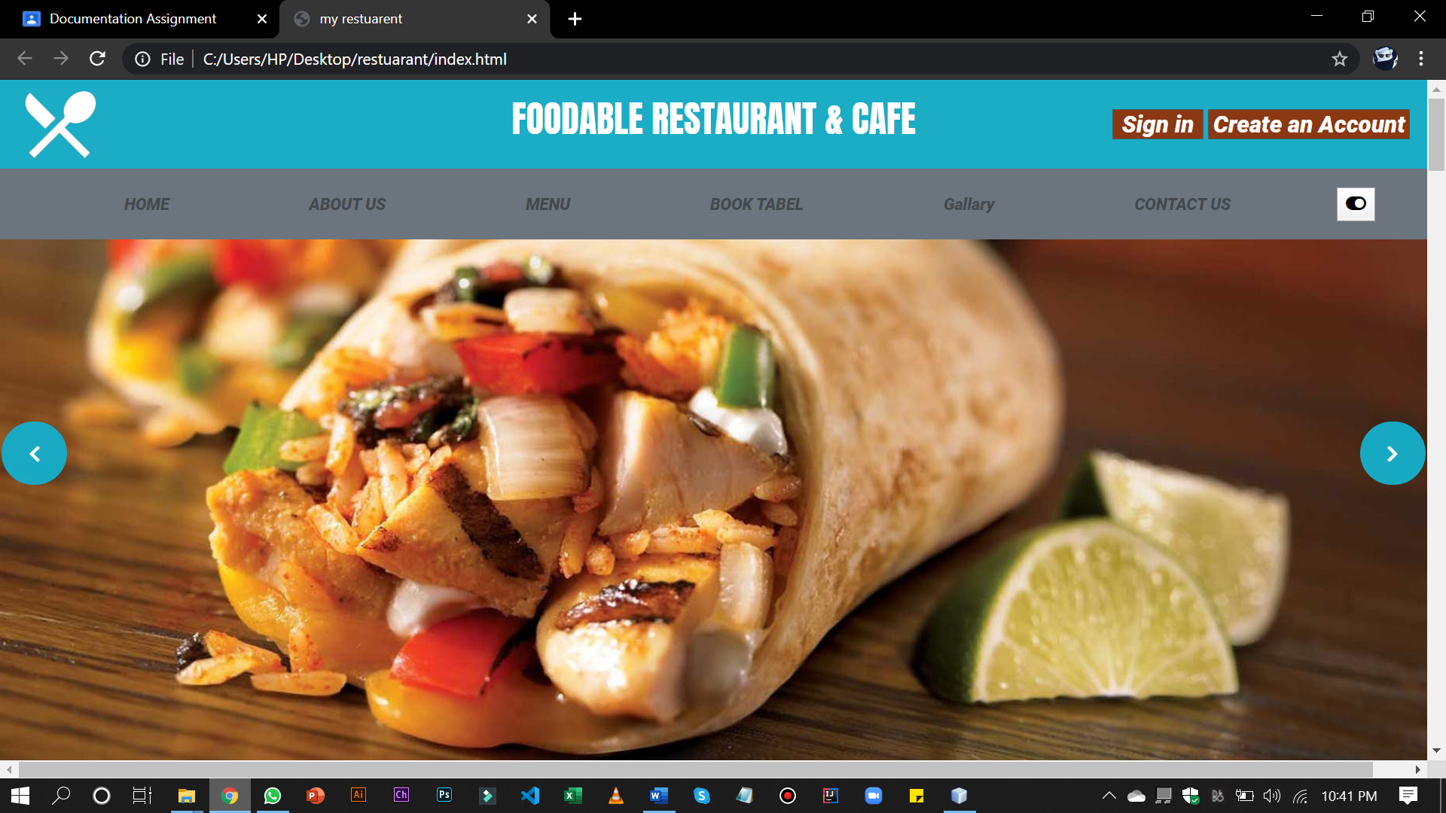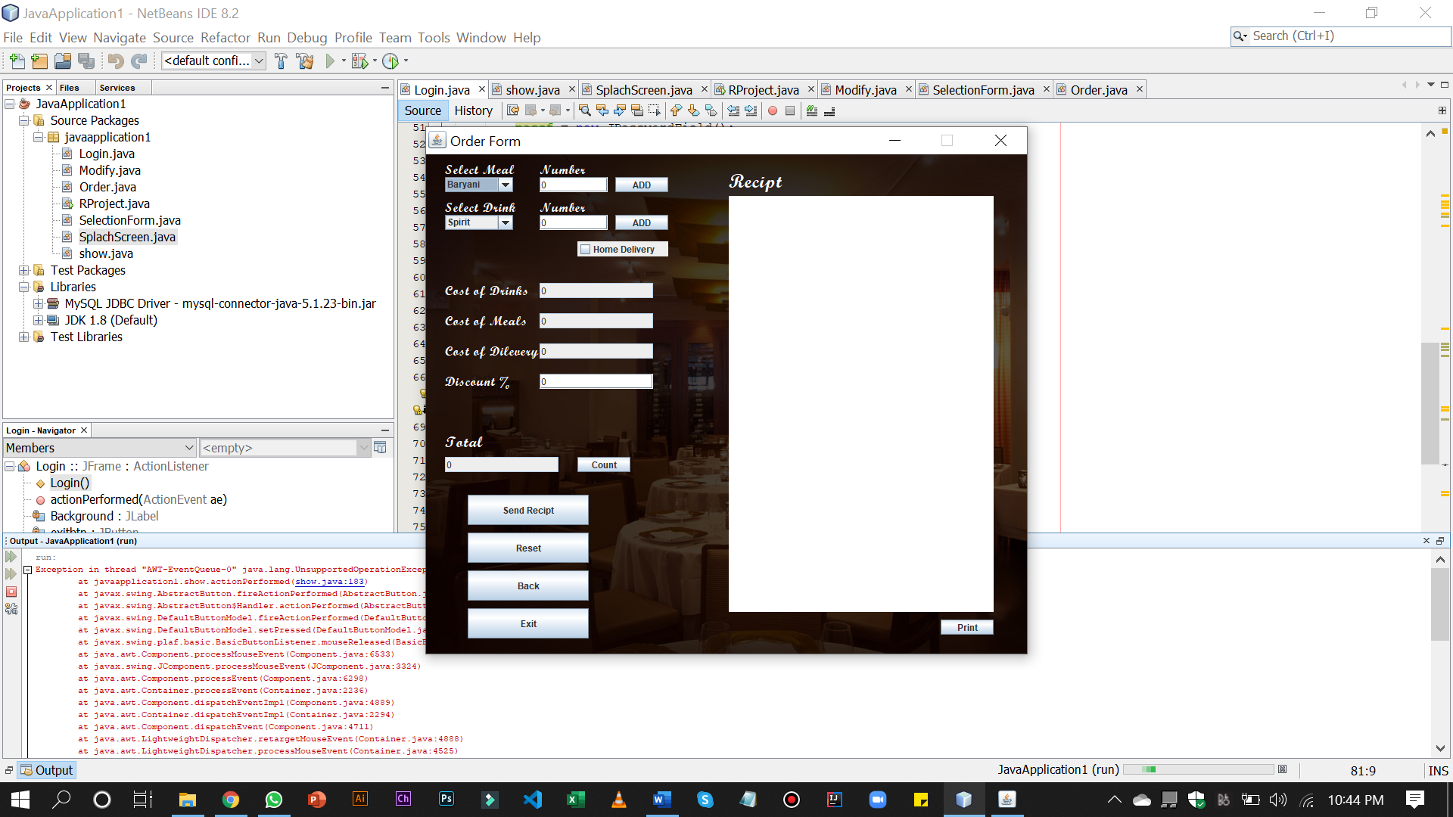

# Reference and Bibliography

**Reference and Bibliography**

[1] Sunway resort hotel and spa

[2] System of “The resort café Restaurant”

[3] <https://www.wikipedia.com>

[4] <https://online.visual-paradigm.com/>

[5] <https://creately.com/>

[6] Book Software Engineering by IAN Sommerville 10th Edition